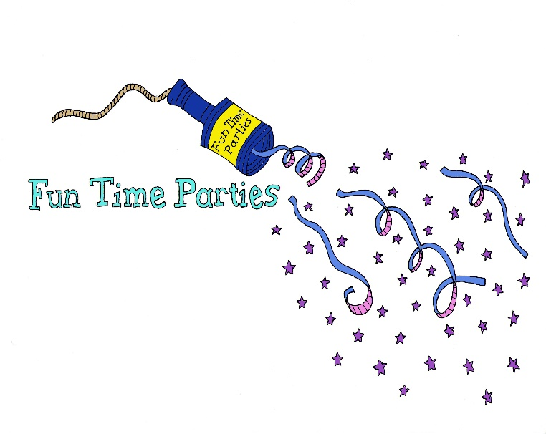

Terms and Conditions:
- The Funtime Parties booking Fee is non-refundable unless Funtime Parties cancel the booking.
- The client must cover congestion charge or parking costs at venue if applicable.
- Cancellation must occur at least 14 days prior to the party date otherwise the full party fee will be required.
- There must be at least 2 adults present during entertainment and the safety of the children lies with the responsibility of the adults present not the entertainer booked. Funtime Parties accepts no responsibility for any incidents that may occur at your event. Your entertainer cannot be held responsible for any injury arising from the games and activities included in the party.
- Our themed parties are a tribute to the original and for trademark & copyright purposes we do not offer the original characters.
- Princess entertainers are not booked as “lookalikes” they are booked as entertainers acting as a particular princess. Our princess dresses are designed to be able to run an active party in. Although every effort is made to book a princess with the correct colour hair, depending on the location of the party and the entertainer available wigs may be used.
- Entertainers that have been specifically requested are subject to change at any point whereby a replacement entertainer of the same standard will be provided. Funtime Parties reserve the right to make changes at short notice.
- Our entertainers use only quality face paints and Glitter tattoos (Snazaroo) which are suitable for sensitive skin. Glitter tattoos contain cosmetic glitter which is Eco Friendly – SGS, ROHS, EN71-73 and we use cosmetic body glue which contains Aqueous Acrylic Polymer. Funtime Parties accepts no responsibility for any guests who have make-up, face painting or any cosmetic allergies. Please check with all your guests before the party begins and inform the entertainer of any allergies.
- All Funtime Parties Entertainers follow a similar party format. However costumes, music, prizes, sound systems, props and equipment may vary between entertainers.
- Funtime Parties shall not be liable to the client or be deemed to be in breach of the contract if there is delay in performing, failure to perform, illness or injury of the entertainer or if the delay or failure is due to any cause beyond Funtime Parties reasonable control, including illness, accident, breakdown, fire, flood, storm or poor weather. Funtime Parties does not offer compensation of any form. Funtime Parties will do their upmost to supply an alternative entertainer for your party and failing to do so we will refund the booking fee.
- If the client needs to change the date of the party due to severe weather or illness as a good will gesture the client may postpone a booked party to another date within 4 weeks of the original booking date if Funtime Parties have availability. Available dates will be offered at the discretion of Funtime Parties and may result in a mid-week slot being offered if the weekends are fully booked. If a postponed date within 4 weeks cannot be agreed by the client then the full party fee will still be payable as per term 3 above.
- Funtime Parties accepts no responsibility for any loss or damages at your party venue.
- If the party theme is not confirmed at least 14 days prior to the party date, it will automatically become our general party “Funtime Party.”
- If Arts and Crafts activities are booked but not confirmed at least 14 days prior to the party date they will be chosen by Funtime Parties. One Arts and Crafts activity will be supplied per 30 mins.
- If UV Party Package is used then please make your guests aware that UV lights are used and Disco Lights will also be used so please check if any of your guests are epileptic.
- If you have booked the UV Party Package then our Entertainers use only quality UV Face Paint.
- If you have booked the UV Party Package then please be aware that all lights in your venue must be switched off for the best effect as if lights are not turned off then you will not glow in the dark.
- If a party theme is requested that is not displayed on the website and we do not have the music within our library the client must supply the requested music for the entertainer to use.
- Your entertainer can withdraw activities if they feel the venue space, flooring or number of children make the activity unsafe.
- You must notify your entertainer of any disabilities, allergies, phobias or injuries the children may have.
- It is the client’s responsibility to check with the venue beforehand if smoke machines and bubble machines and snow machines can be used. If the machines are used and the client has not checked this with the venue then Funtime Parties will not accept any responsibility.
- Once a booking has been made and booking form supplied by Funtime Parties any changes to the booking information will incur a £15 administration charge.
- By paying the Booking Fee to secure the booking you are agreeing to the terms and conditions above.

Please note that by paying the Booking Fee you have agreed to the terms and conditions on this booking form.

Funtime Parties Ltd, 316 Ladysmith Road, Enfield, Middlesex, EN1 3AF
www.funtimepartiesltd.co.uk : funtime-parties@outlook.com
Funtime Parties Ltd, Company number: 09298579

